FocusCo Photographer Request Form

When requesting FocusCo for photographers for an event, please fill this form two weeks in advance of the event, and hand it to a FocusCo Board via email (focusco@ucsa.nl). Any form handed in late will be disregarded.

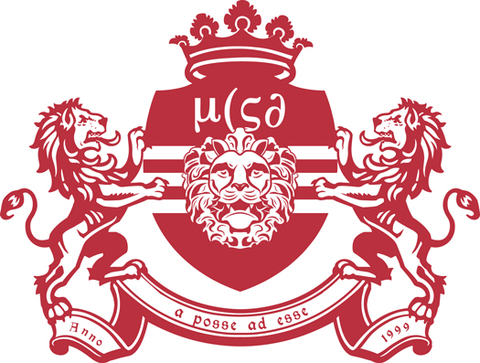
As our photographers work on voluntary basis, we would appreciate for some kind of compensation for the photographers (e.g. free entry, free drinks).

Committee name:
Contact person:
Contact email:
Event Name:
Date:
Time:
Venue:
Compensation:

Please note that photographs taken during the event will be uploaded as soon as possible, but it may take up to one week. We kindly ask you for your patience.

FocusCo Board 2016 - 2017
Chair Simona Tomáseková
Vice-Chair Maaike Blom
Secretary Emily Holthuis
Treasurer Florine Kist
Public Relations Laura Hoogenraad

