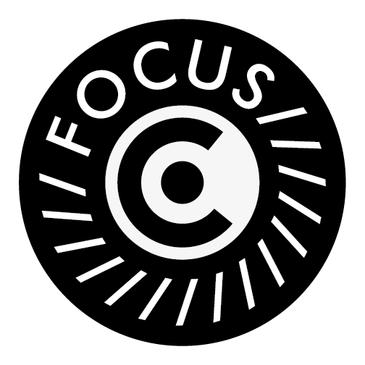
FocusCo Photographer Request Form

When requesting FocusCo for photographers for an event, please fill this form 10 days in advance of the event, and send it to the FocusCo email (focusco@ucsa.nl).

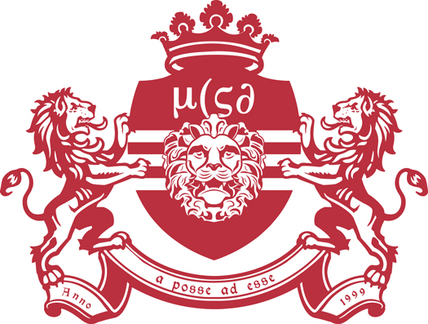
As our photographers work on voluntary basis, we would appreciate for some kind of compensation for the photographers (e.g. free entry, free drinks).

Committee name:
Contact person:
Contact email:
Event Name:
Date:
Time:
Venue:
Compensation:

FocusCo Board 2021 - 2022
Chair Alicia Derksen
Vice-Chair Meike Span
Secretary Seren Carmody
Treasurer Charlotte Smeets
Public Relations Sam Hoffman
Events Manager Lieve Van Borssum

