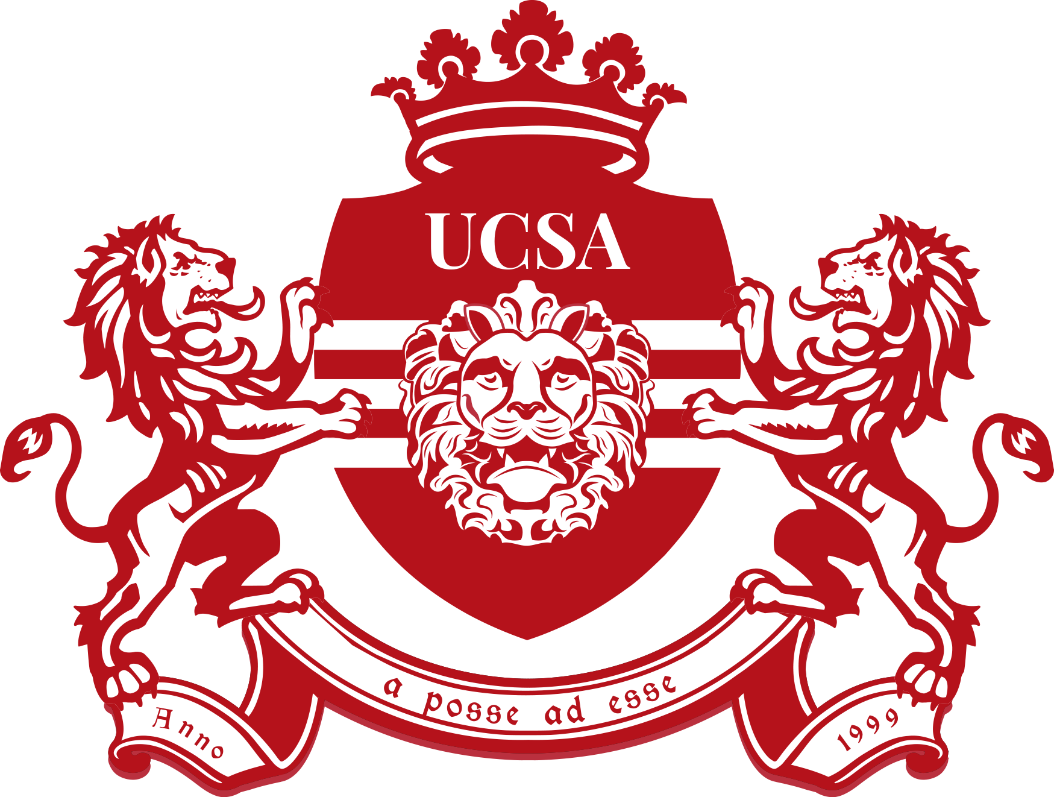
MusicCo Request Form

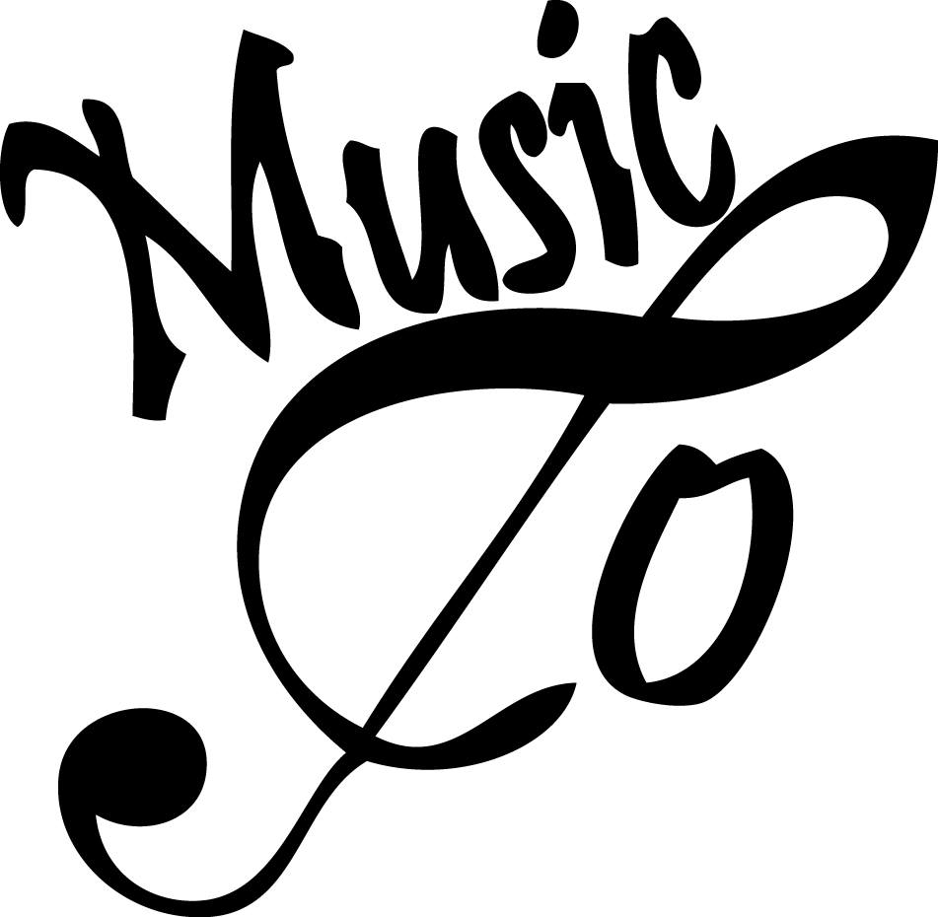
Thank you for showing interest in collaborating with MusicCo! This form serves to give us a clear understanding of what you want from us, so that we can save ourselves from emailing back and forth.

Please answer the following questions and send this document to musicco@ucsa.nl at least two weeks before your event will take place. We will try to get back to you as soon as possible.

What committee are you?

Who are your board members?

When is your event going to take place?

Describe the event you want to organise, and what role you want us to play in it.

Please include (if applicable):
- If you need our music instruments and equipment
- If you need us to provide music and if yes, what kind of music
- How long your event is going to take
- Whether you or your committee will provide help setting up and/or cleaning up
- Whether you want us to help promote your event
- Where you are organising your event

Thank you for your cooperation!

MusicCo Board 2018/2019
Haram Chair
Iris Secretary
Betsy Treasurer
Laura PR manager
Douwe Equipment manager
Noud Equipment manager

