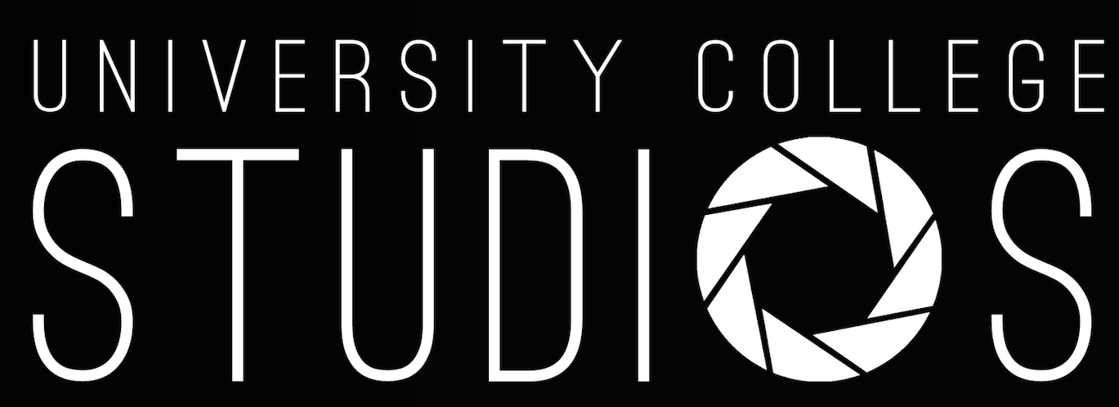

EQUIPMENT REQUEST FORM / FILM REQUEST FORM

Please fill in this form for an equipment request five
days in advance of the event and send it to
ucstudios@ucsa.nl

UCStudios Board Fall 2019:

Chair: Anne-Marijn Oosterholt
Secretary: Marta Pausilli
Equipment Manager/Treasurer: Anne Schuurmans
Crew Manager: Sofia Houthuysen
Public Relations: Vicky Pinheiro Keulers
Project Manager: Lora Apostolova
Creative Director: Doris Vlaar

General information:
Name of committee:
Contact person:
Contact email:
Contact number:
Request for filming or equipment:

Equipment request:
Requested equipment:
How long is the equipment needed for (max. 1 week):
Purpose of requested equipment:
Name of event/project:
Date of event/project:
Time of event/project:

Film request:
Please specify what you would like to get filmed by UC-Studios:
Please specify what should be considered important while filming your project:
Please specify what/how many crew members you will need:
Please specify the date(s) and time of the project:
Will you be editing the footage yourself or is UCStudios needed:
Any other important notes:

As our work is voluntary based on our love for filming, our team would kindly appreciate a form of compensation.

UCStudios will aim to complete the filming request as soon as possible, however UCStudios also has the right to determine the working period according to the given request. Our minimum editing period is one week . We kindly ask you for your patience.

