Photographer Request Form

Dear Committees and others,

When requesting FocusCo for photographers for an event, please fill this form two weeks in advance, and hand it to the FocusCo Board via email (focusco@ucsa.nl). Any form handed in late will be disregarded.
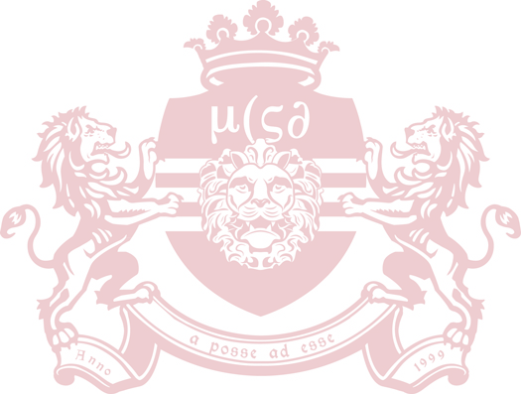
As our photographers work on voluntary basis, we would appreciate for some kind of compensation for them (e.g. free entry, free drinks, …).

Committee name:
Contact person:
Contact email:

Event Name:
Date:
Time:
Location:

Compensation:

Please note that photographs taken during the event will be uploaded as soon as possible, but it may take up to one week. We kindly ask you for your patience.

Sincerely,
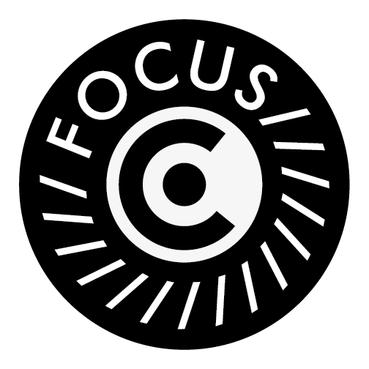
FocusCo Board 2020 – 2021
Willem Grootoonk– Chair
Noes Petiet – Vice Chair
Julia Zonneveld– Secretary
Sabine Hillen– Treasurer
Sam Hofman – Public Relations

