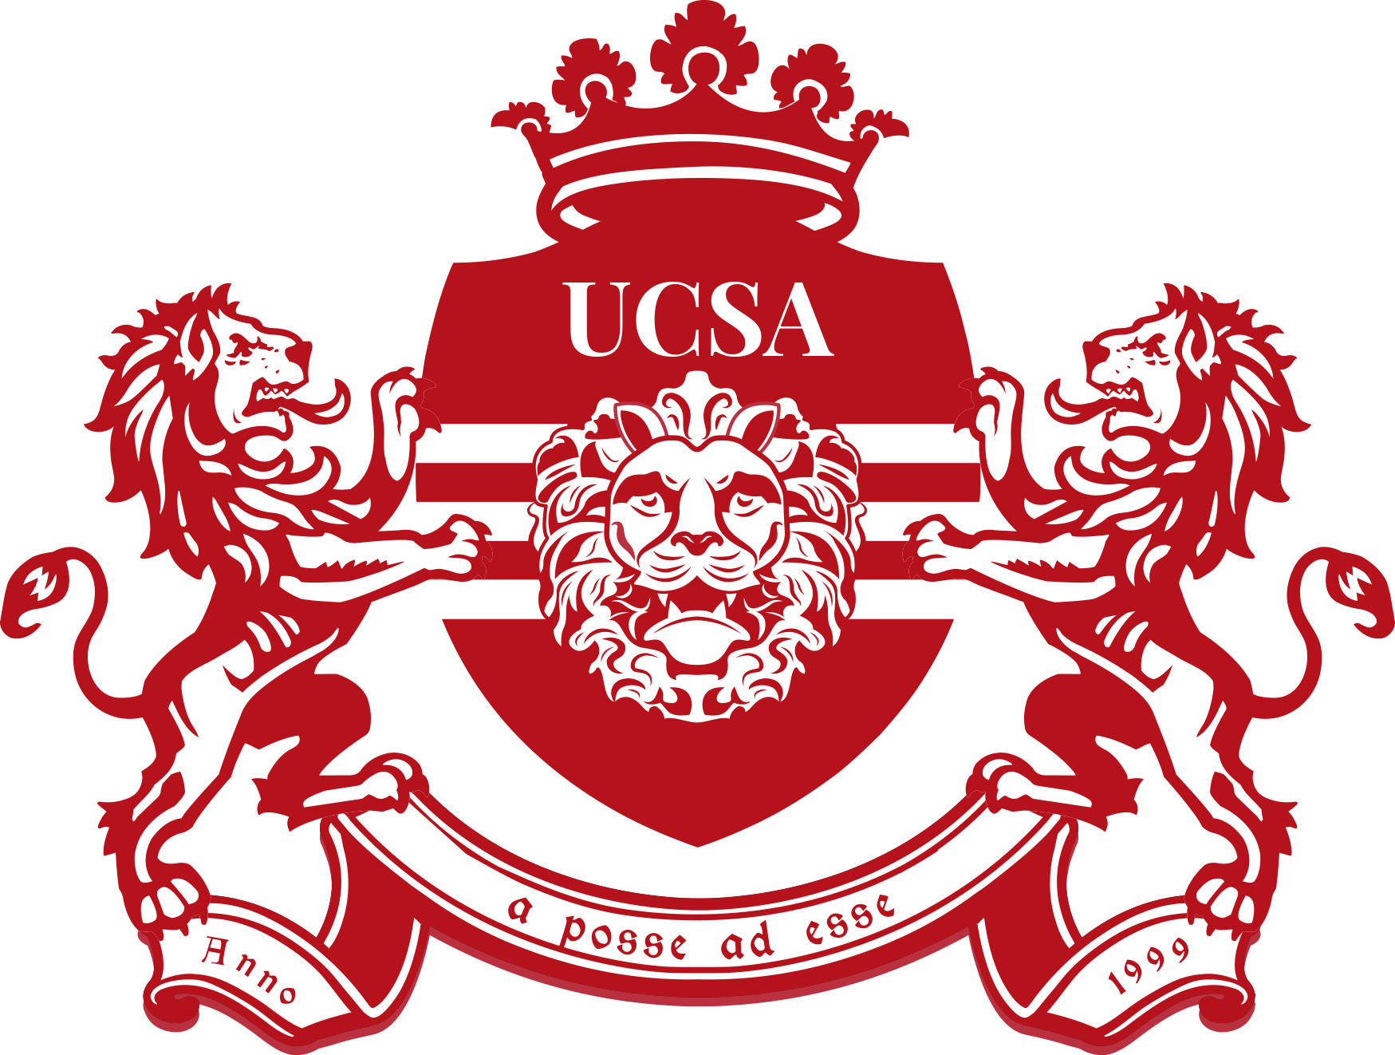

University College Student Association
Board Merch Reimbursement form 2022-2023

Please note that reimbursement will only be granted by the UCSA Treasurer after this form has been handed in with the corresponding receipts that can be attached at the end of this document, no more than 31 days after the expense has been made.

Please send this reimbursement form to diego.roell@ucsa.nl.
Please send it in PDF form
The receipts attached should state the products or services bought, which means PIN transaction receipts are not accepted.
By submitting this form you certify that this document has been filled in truthfully.

Recipient of reimbursement
Name and surname
Account number / IBAN
Phone number
Email address

Details of the expense
Amount of money spent
Amount of money to be reimbursed*
Date of the expense
UCSA Committee / Team
Details of the expense (extra information about the products bought for example)

The name of the board member(s) receiving merch

*If the amount of money to be reimbursed is above 100 euros please mark your email as “priority” before sending it to diego.roell@ucsa.nl

Please put a scan or picture of the receipt or invoice of the expense here:

Please put a picture of the board merch here:

