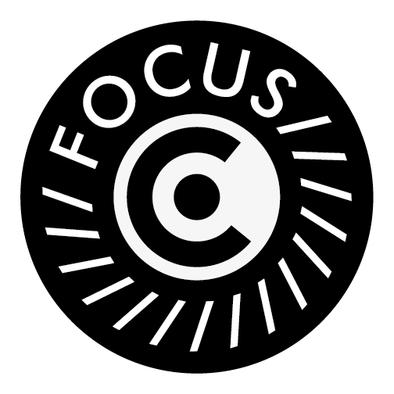
FocusCo Photographer Request Form

When requesting FocusCo for photographers for an event, please fill this form 10 days in advance of the event, and send it to the FocusCo email (focusco@ucsa.nl).

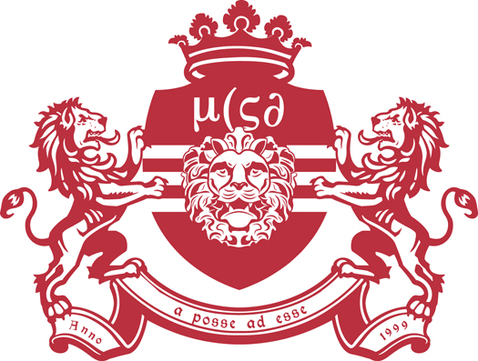
As our photographers work on voluntary basis, we would appreciate for some kind of compensation for the photographers (e.g. free entry, free drinks).

Committee name:
Contact person:
Contact email:
Contact phone number:
Event Name:
Date:
Time:
Venue:
Compensation:

FocusCo Board 2022-2023
Chair Alicia Derksen
Secretary Lidewij Nijenhuis
Public Relations Annemijn Jekel
Editor 1 Cemre Birman
Editor 2 Maja Anuszewska
Events Manager Zsófia Lehóczky

