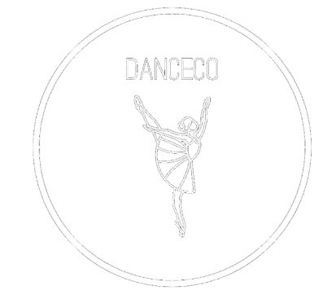
DanceCo Equipment Form
Please send your request via email (danceco@ucsa.nl) at least 1 week in advance. If the request is approved, we will email you back, specifying when and where the requested equipment can be picked up, as well as returned back.

In the case that the equipment is returned with damage that was not there at the time the equipment was handed to the borrower, the borrower will be held accountable and charged for any costs made to repair or replace the borrowed equipment.

Equipment available: Standing led lights (x2), Speaker

Equipment needed:
Date:
Time:
Committee name (if applicable):
Contact person:
Contact phone number:
Signature:

University College Student Association DanceCo Board 2022-2023
Chair - Bianca Spiegelberg
Vice-Chair - Dana Kniest
Secretary - Giulia d'Angelo
Treasurer - Kitty Bertrand
Class coordinator - Emilia Seidl
PR-manager - Nicole Spiegelberg

